A**ccess MySQL database from Python**

**Prepare MySQL database:**

Use XAMPP platform to prepare your MySQL database. We will now proceed, assuming you already have a database ready, running on a localhost.

**Install required S/W, packages:**

* Follow instruction in following link to install python, pip and setting PATH variables. The instructions are for windows users, but for linux/Mac users steps are much easier.

<https://github.com/BurntSushi/nfldb/wiki/Python-&-pip-Windows-installation>

* Then install PyMysql as : pip install pymysql

**Running Python code:**

1. Open, understand and run following file first.

ConnectToPysql.py

You can use community version of PyCharm community edition software for running the python code. : <https://www.jetbrains.com/pycharm/download/#section=windows>. You can also use default IDLE coming with python to write, and run python code.

1. For data visualization from python: install followings

pip install plotly

pip install pandas

pip install cufflinks

pip install -U matplotlib

Now open, read comments to understand the code and execute following file using default IDLE or PyCharm:

PyMsql.py

1. [Optional- but highly recommended] Now using some object-oriented concept try to understand code in “ConnectToDB.py” , “RunQuery.py” and “Testing.py”. Run Testing.py to see output
2. As we have seen jupyter Notebook allow you to execute python code, interact with database, visualize them at single place. You can install Anaconda to install both python and Notebook. (Since it is a different environment/ framework package, you might need to install pymysql, plotly, pandas and matplotlib in Anaconda environment again) Link for Anaconda is below:

<https://conda.io/docs/user-guide/install/index.html>

After installing everything, lunch Jupyter Notebook, open following files and execute every segment separately.

visualization.ipynb

1. mysql-basic.ipynb [Optional- but highly recommended]- This code is based on “RunQuery.py” mentioned in (3)

Note: Please make sure you put all python files and mysql-basic.ipynb in the same directory. The default document root/Target directory for Jupyter Notebook is C:\Users\YourUsername. If you want to change the target directory, follow the instructions from following link:

<https://jupyter-notebook-beginner-guide.readthedocs.io/en/latest/execute.html>

or

<http://www.calvin.edu/~sld33/InstallPython.html>

**====== Do not want to use Anaconda or Old Python? Follow the discussion below =====**

**Installing Python 3.7 and Jupyter Notebook Separately**

* create a folder in any drive in your laptop- Say “python” in C:\
* Download latest version (3.7) of python from following link:

https://www.python.org/downloads/

* Install it , select customize installation when you see the following window, it will allow you to select programs you want to install, Keep all selections default. Select installation location in your preferred directory C:\python or you can also keep it default location but write down the location you are installing in, you need it later.

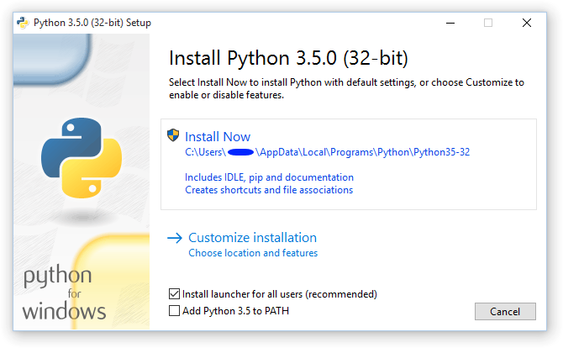



* Setup environment variable, so that you can access python and pip very easily. For that search environment in search location in your window and add two new paths in the PATH variable.

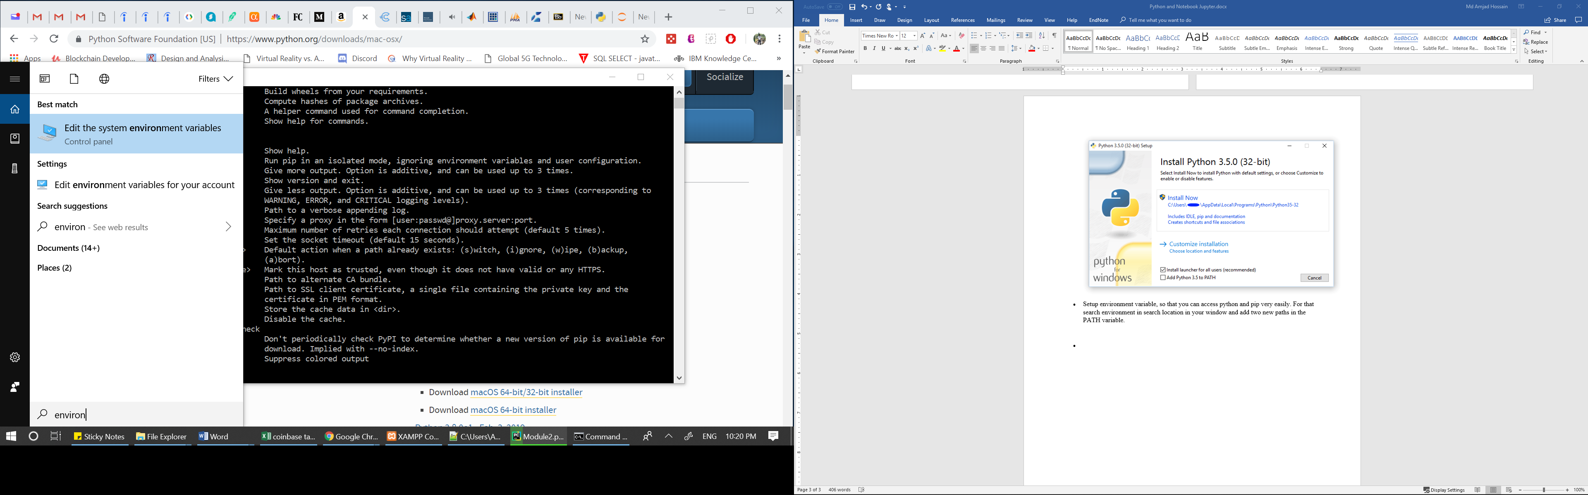



* Click on “Environment Variables”
* Double click on “Path” variable in “User variables” area
* Click on New and add two paths as shown below. These two paths are for “Python” and “pip: package manager. You have to add these paths according to your installation path of python.
* 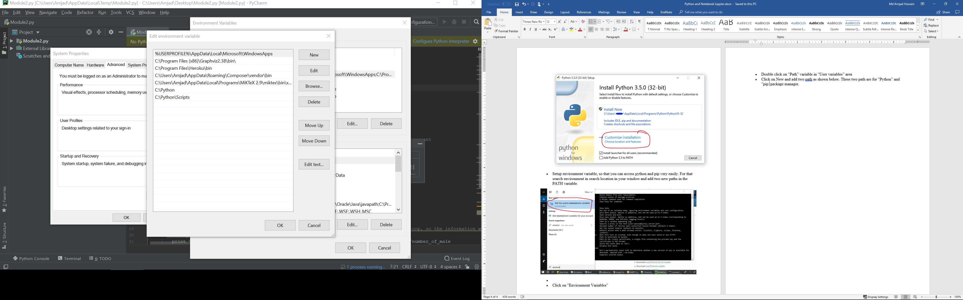



* Now if you open command prompt and write “python” then you should see following:

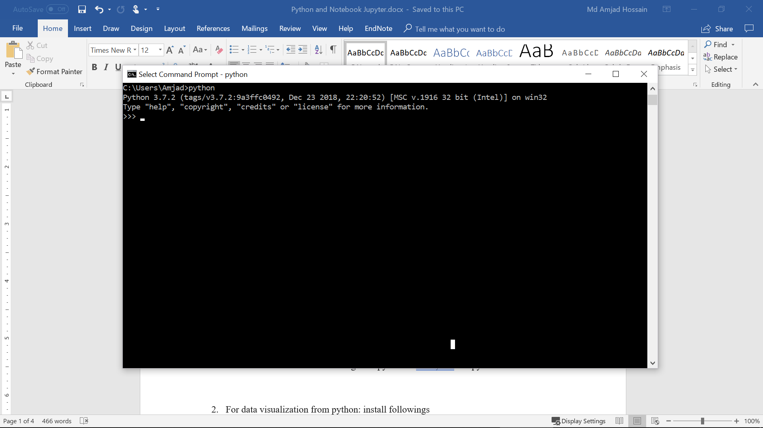

* Exit from the python prompt as writing exit(1), and execute following commands to install “pymysql” connector, pandas and matplotlib
* Pip install pymysql
* Pip install pandas
* Pip install matplotlib
* Now install jupyter notebook using following two commands
* python -m pip install --upgrade pip
* python -m pip install jupyter
* Now you can run notebook jupyter as follows from the command prompt:
* jupyter notebook

This should open the Jupyter Notebook in the browser listing all folder and files from the target directory of Notebook.

Now you are ready to run codes on the notebook

Note: The python codes provided are written in Python 2.7, so you might need minor changes in the code to run them in Python 3.7.